STEPHEN STUBBS BIOGRAPHY 2018

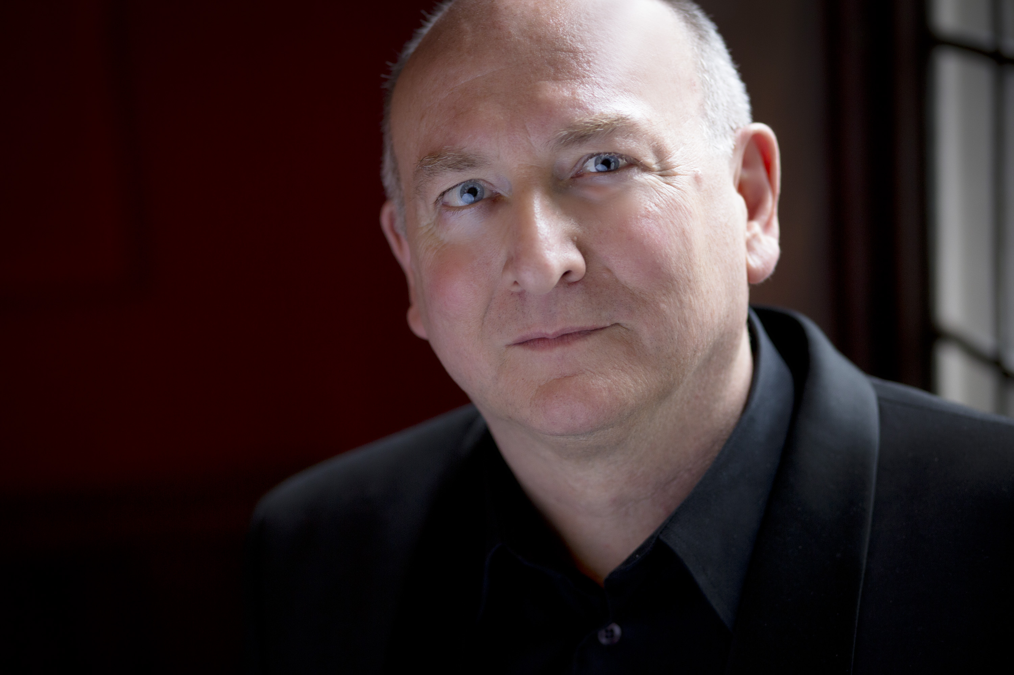

Stephen Stubbs, who won the GRAMMY® Award as conductor for Best Opera Recording 2015, spent a 30-year career in Europe. He returned to his native Seattle in 2006 as one of the world’s most respected lutenists, conductors, and baroque opera specialists and in 2014 was awarded the Mayor’s Arts Award for ‘Raising the Bar’ in Seattle. Before his return, he was based in Bremen, Germany, where he was Professor at the Hochschule für Künste.

In 2007 Stephen established his new production company, Pacific MusicWorks, based in Seattle, reflecting his lifelong interest in both early music and contemporary performance. The company’s inaugural presentation was a production of South African artist William Kentridge’s acclaimed multimedia staging of Claudio Monteverdi’s opera The Return of Ulysses in a co-production with the San Francisco Museum of Modern Art. PMW’s performances of the Monteverdi Vespers were described in the press as “utterly thrilling” and “of a quality you are unlikely to encounter anywhere else in the world”. In its celebratory tenth season (2017/18) Pacific MusicWorks will release its first commercial recording: Handel’s Tenor featuring GRAMMY® Award-winning Tenor, Aaron Sheehan.

Stephen is also the Boston Early Music Festival’s permanent artistic co-director along with his long-time colleague Paul O’Dette. Stephen and Paul are also the musical directors of all BEMF operas, recordings of which were nominated for five GRAMMY awards, and won the GRAMMY for Best Opera Recording 2015. Also in 2015 BEMF recordings won two Echo Klassik awards in Germany, and the Diapason d’Or de l’Année in France. In 2017 they were presented with the Preis der deutschen Schallplattenkritik.

In addition to his ongoing commitments to PMW and BEMF, other recent appearances have included Handels’ Giulio Cesare and Gluck’s Orfeo in Bilbao, Mozart’s Magic Flute and Cosi fan Tutte for the Hawaii Performing Arts Festival, Handel’s Agrippina and Semele for Opera Omaha, Cavalli’s Calisto and Rameau’s Hippolyte et Aricie for Juilliard, Mozart’s Il re pastore for the Merola program and six productions for Opera UCLA including Cavalli’s Giasone, Monteverdi’s Poppea and Handel’s Amadigi. In recent years he has conducted Handel’s Messiah with the Seattle, Edmonton, a Birmingham and Houston Symphony orchestras.

His extensive discography as conductor and solo lutenist include well over 100 CDs, many of which have received international acclaim and awards.

From 2013-2018 Stephen Stubbs held the position of Senior Artist in Residence at the University of Washington School of Music. During this tenure he produced and conducted Handel’s Semele, Mozart’s Zauberflöte, Gluck’s Orphée, Cavalli’s Calisto, Purcell’s Dido and Aeneas and Ravel’s L’Enfant et les Sortilèges.

Stephen is represented by Schwalbe and Partners.

